MID-TERM EXAM Study Guide

Ms. Eddleston
ELA Enrichment
Know vocabulary:
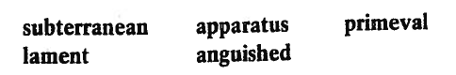
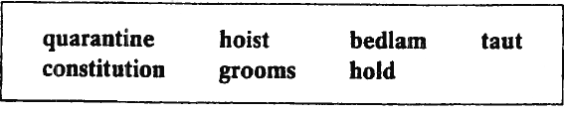

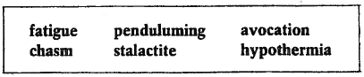

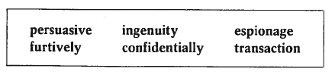

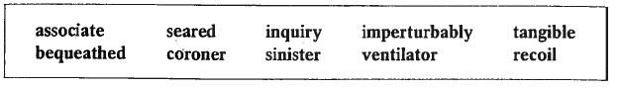

Be able to identify by definition or an examples of:

simile metaphor personification science fiction
flashback foreshadowing realistic fiction repetition
nonfiction dialect setting formal language
informal language

Know from short stories:

39. Which story includes a character named Pat?
40. Which story describes bacon rind drapery?
41. Which story includes a character named Dr. Roylott?
42. Which story includes a character named Alec?
43. Which story includes a character named Helen?
44. Which story is Science Fiction?
45. Which story includes the sinking of a ship?
46. Which story is nonfiction?
47. Which story includes a creature resembling a dinosaur?
48. Which story is a play?
49. Which story is realistic fiction?
50. Which story includes a character named Fowler?
Name ___________________________ Date ______________________

Block__________ ELA Enrichment
Mid-Year Exam ROUGH DRAFT
“The Fog Horn” by Ray Bradbury

- Describe the emotions (3) felt by the creature at the beginning, middle, and end of the story. Support your answer with specific incidents from the story.  Include a relevant quote from the text to support each of the three emotions. You will need to include THREE CORRECTLY CITED quotes in your response.  NOTE: YOU MAY BRING TO CLASS AND USE YOUR ROUGH DRAFT COMPLETED AT HOME ON THE DAY OF THE MIDTERM.  See my sample response on my classroom website and refer to your graded group response as references.  You MUST use the “belly quote” in your response.  Be sure quotes and citations are correctly worded. (The three options are on the back side of this page.) | In “The Fog Horn” by Ray Bradbury, the creature experiences many emotions. The sea creature starts off feeling lonely. McDunn explains, “All year long, Johnny_____________________________________  __________________________________ and twenty miles deep” (Bradbury 127). Its emotions then move to excitement and anticipation after hearing the Fog Horn. The monster’s excitement is described as “the furnace______________  up” (Bradbury 127) and includes the creature’s journey to the lighthouse. Finally the sea creature ends up tormented and anguished and after attacking the lighthouse, returns to its loneliness. The text describes the sea creature’s actions: “its eyes caught fire. It reared up, _____________________________  _____________________________filled with angry torment” (Bradbury 128).

Rubric: | 50 | 40 | 30 | 20

Question #1  Describe the emotions felt by the creature at the beginning, middle, and end of the story. Support your answer with specific incidents from the story. | The response is a clear, complete, and accurate explanation of the emotions felt by the creature at the beginning, middle, and end of the story. The response includes relevant information from the excerpt. | The response is a mostly clear, complete, and accurate explanation of the emotions felt by the creature at the beginning, middle, and end of the story. The response includes relevant but often general information from the excerpt. | The response is a partial explanation of the emotions felt by the creature at the beginning, middle, and end of the story. The response includes limited information from the excerpt and may include misinterpretations or inaccuracies. | The response is a minimal explanation of the emotions felt by the creature at the beginning, middle, and end of the story. The response includes little or no information from the excerpt and may include misinterpretations or inaccuracies.

