Name: _____________________ Date___________
Block_______ ELA Enrichment 7

The Outsiders Setting Cinquain Poem
Directions: Write a cinquain poem that describes an important setting in The Outsiders.

A cinquain has five lines/ 2 4 6 8 2 syllable pattern / one full sentence / all lines start with a capital letter.

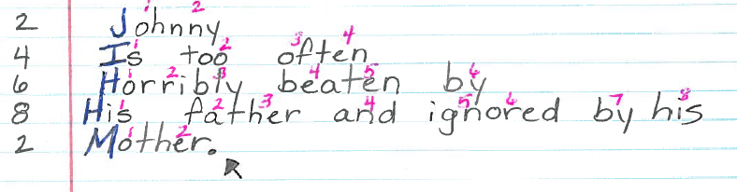
Identify your chosen setting: _________________________________.

Number the syllables for each line as I did in pink in the character cinquain example above. Please use a bright or distinct color.
(Please use rough draft paper to plan.)

2 __________________________________________
4 __________________________________________
6. __________________________________________
8. __________________________________________
2. __________________________________________

Grading:  - five-lined, correct syllable pattern.  (20 points, 4 per line)  - ONE sentence form. (20 points)  - Each line begins with a capital letter.  (5 points)  - The last line only ends with a period.  - points) | - _____/ 20  - _____/ 20  - _____/ 5  - _____/ 5  Score: _____/ 50 _________ %

