Gr. 7H English / Ms. Eddleston
Summer Reading Assessment (to be completed in class)
Date: 9/19/17 (Bring your book!)

Directions: Respond to one of the following prompts as it relates to your book:
- Identify one minor character (person) who is important to the story. Describe the character using details (evidence) from the book and explain why he or she is important to the work as a whole. Include at least one correctly punctuated quote (use exact words from the book) and explain how this quote supports your response.
- Compare and contrast two of the characters in the book. Describe the characters’ personality traits (motivations and behaviors) using at least two quotes (evidence) from the book. Explain how each quote supports your response.
- Select two quotes (evidence) from the text that exemplify how the setting affects the mood of the story. Explain how each quote supports your response.
- Student proposal of self-generated prompt (must be evidence-based): ___________________
____________________________________________________________________________________________________________________________________________________________________________________________________________________________________________________________________________________________________________________
Request teacher approval by 9/15/17. (Teacher’s signature): ___________________________
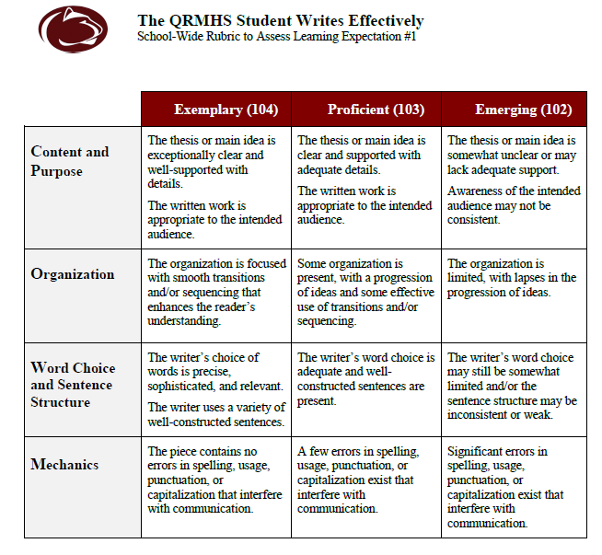
In-Text Quotations & MLA Citations

When using quotations (textual exact words) as evidence in a written response or essay, gracefully incorporate them into your writing by imbedding quoted words into your own original sentences. (Includes MLA Modern Language Association (of America) in-text citations)

NOTE:
PLEASE DO NOT introduce a quotation by writing: “The following quote shows…”
PLEASE DO NOT just drop a quotation in your essay as a standalone sentence.

Examples (from The Adventures of Huckleberry Finn by Mark Twain) of imbedded quotes:

- Use a statement and a colon to introduce a quote:
At the end of the chapter, Twain’s Huck takes a significant step toward recognizing Jims’ humanity: “I didn’t do him no more mean tricks, and I wouldn’t done that one if I’d ‘a’ know’d it would make him feel that way” (111).

- Use a speaking verb and a comma to introduce a quote:
Huck is not trying to be funny when he says, “Sometimes I wish we could hear of a country that’s out of kings” (Twain 199).

- Use a short quoted fragment:
Ironically, the most moral act Huck commits causes him to believe that he’ll “go to perdition” (Twain 273) for doing it.

Primary Source: http://drake.marin.k12.ca.us/academics/englishhandbook.pdf

More in-text citation examples:
The author's name may appear either in the sentence itself or in parentheses following the quotation (or paraphrase), but the page number(s) should always appear in the parentheses, not in the text of your sentence. For example:

Wordsworth stated that Romantic poetry was marked by a "spontaneous overflow of powerful feelings" (263).
Romantic poetry is characterized by the "spontaneous overflow of powerful feelings" (Wordsworth 263).

Wordsworth extensively explored the role of emotion in the creative process (263).

