Name_______________ Date___________
Block ____ ELA Enrichment
The Fog Horn Vocabulary Illustrations
subterranean: | 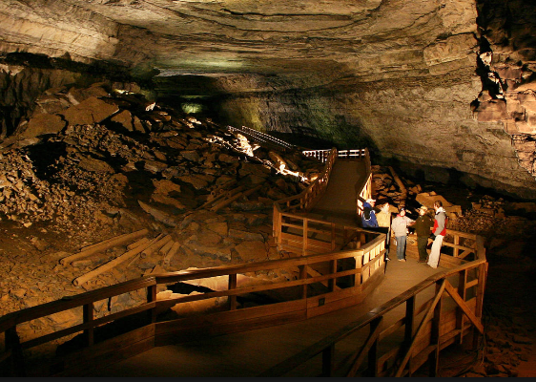 |  |  |  | 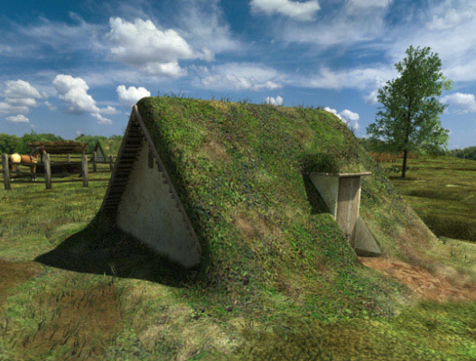
lament:
primeval: | 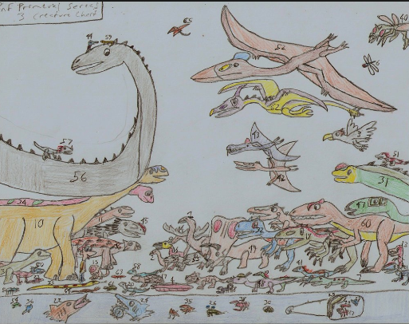 |  | 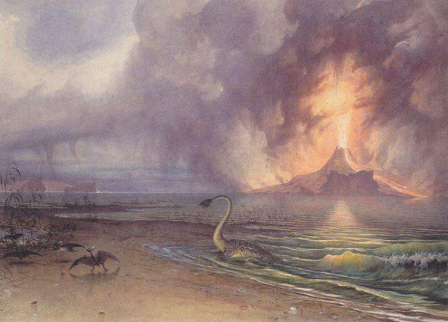
apparatus: | 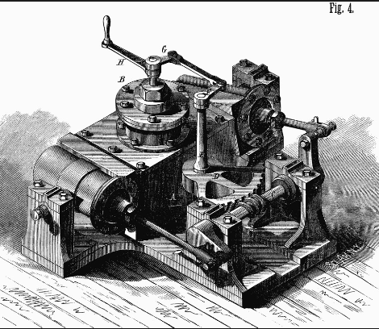 |  |  | 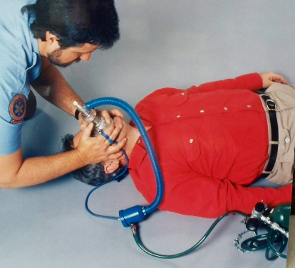
anguished:

Name_______________ Date___________
Block ____ ELA Enrichment
The Fog Horn
Vocabulary Illustrations QUIZ

subterranean lament primeval
apparatus anguished

_______________
_______________
subterranean lament primeval
apparatus anguished

_______________
_______________
_______________

