Name_______________ Date___________
Block ____ ELA Enrichment
The Midnight Visitor Vocabulary Illustrations
confidentially:
ingenuity:
transaction: |  |  | 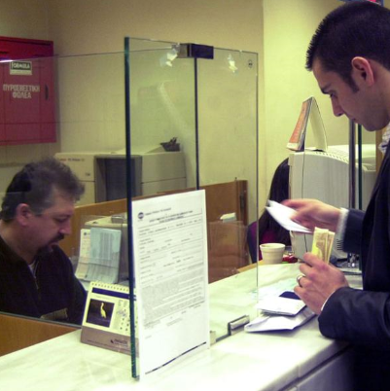
espionage:
persuasive: | 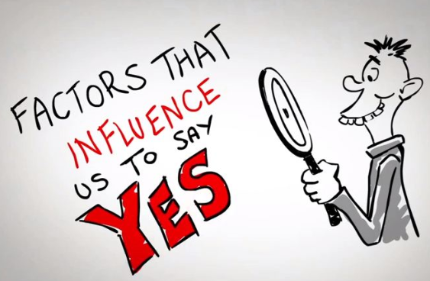 |  |  |  | 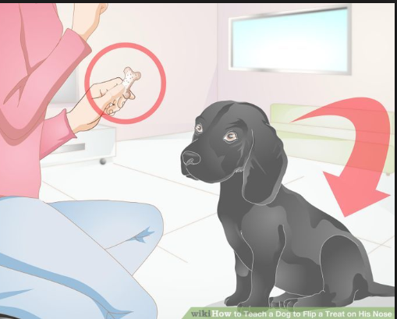
furtively: | 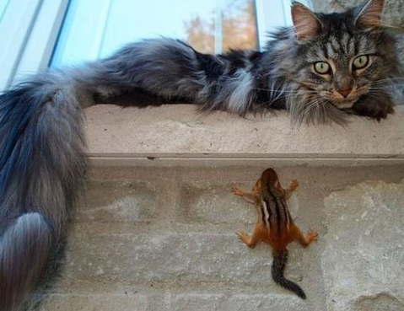

Name_______________________ Date___________
Block ____ ELA Enrichment
The Midnight Visitor
Vocabulary Illustrations QUIZ
persuasive ingenuity furtively
espionage transaction

_______________
_______________
_______________
persuasive ingenuity furtively
espionage transaction
_______________
_______________
_______________

