Name_______________ Date___________
Block ____ ELA Enrichment
The Rule of Names Vocabulary Illustrations
default: |  |  |  | The other team didn’t show up, so they won by default.
cargo: | 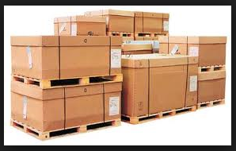
effective: |  | This is an effective  way to move  a boat!
curriculum:
cunning:
Inefficient: |  |  | This is  not working very well!

Name_______________ Date___________
Block ____ ELA Enrichment
The Rule of Names
Vocabulary Illustrations QUIZ



