Name_______________________ Date___________
Block ____ ELA Enrichment
The Speckled Band Vocabulary Illustrations
associate:
seared: | 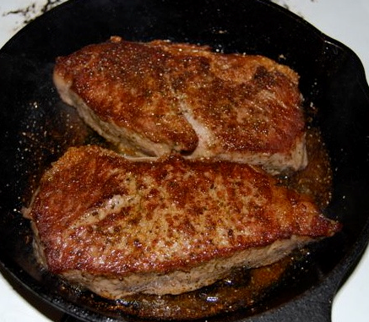
inquiry: |  |  | 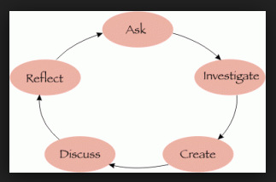
tangible: | 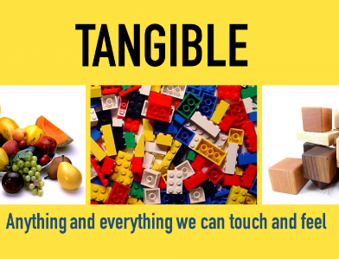
imperturbably: | listening calmly
coroner:

sinister:
recoiled: | 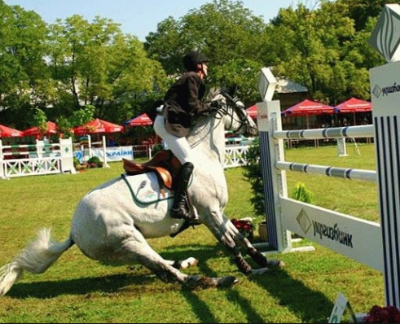 |  |  |  | 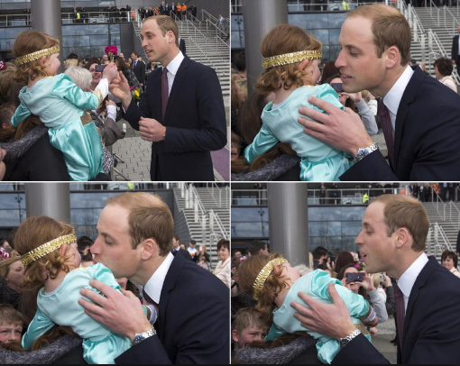
ventilator: | 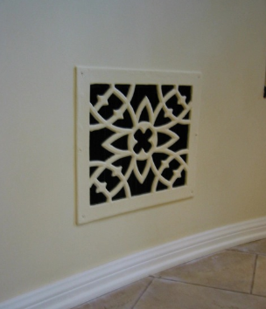 |  |  |  | 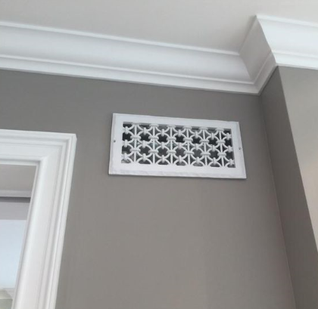
bequeathed:

Name_______________________ Date___________
Block ____ ELA Enrichment
The Speckled Band
Vocabulary Illustrations QUIZ
associate seared inquiry tangible imperturbably
coroner sinister recoiled ventilator bequeathed
_______________
_______________
_______________
associate seared inquiry tangible imperturbably
coroner sinister recoiled ventilator bequeathed
_______________ | 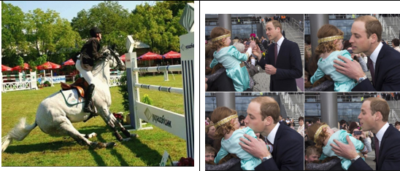
_______________ | 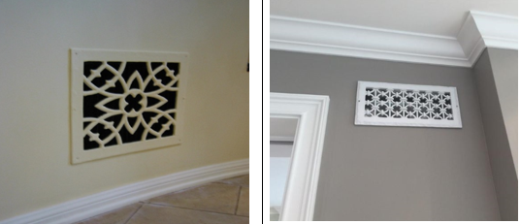
_______________

associate seared inquiry tangible imperturbably
coroner sinister recoiled ventilator bequeathed
_______________ | 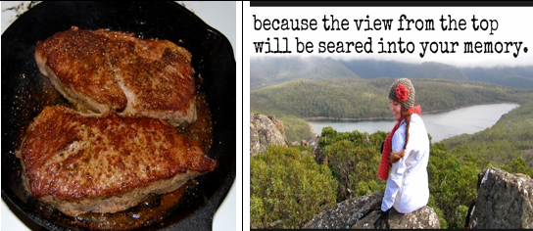
_______________
_______________

associate seared inquiry tangible imperturbably
coroner sinister recoiled ventilator bequeathed
_______________

